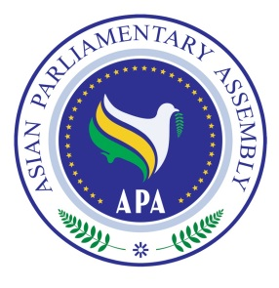
Asian Parliamentary Assembly
The 11th Plenary Session

Standing Committee on Political Affairs
and Working Group on
Asian Parliament

30 November 2018
Istanbul – Turkey

Draft Agenda
1- Adoption of the Agenda
2- Election of the Bureau
3- Opening Remarks by Chairperson of the Meeting
4. Report by H.E. Dr. Ali Khorram, Deputy Secretary General of APA
5- Consideration of the Asian Parliament Working Group
6 - Consideration of Draft Resolutions recommended by the Executive Council
7- Any other matters.

As of 27 November 2018

